Pearson/HMH - Holt/McGraw Hill Resources
Student Access

Textbook apps must be downloaded from Self Service first!
Students/Teachers access textbooks for McGraw Hill and Textbooks through Eanes Account Portal. Students and staff can locate the Eanes Account link on their School’s website OR you can click on the following URL to go to the site: https://idauto.eanesisd.net
*It is recommended that students create a shortcut to the Eanes Account Portal

Below is a QR code that will take any mobile device to the Eanes Account Portal
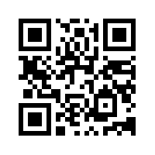
Once students click Eanes Account Portal they will be directed to RapidIdentity to login (see below).
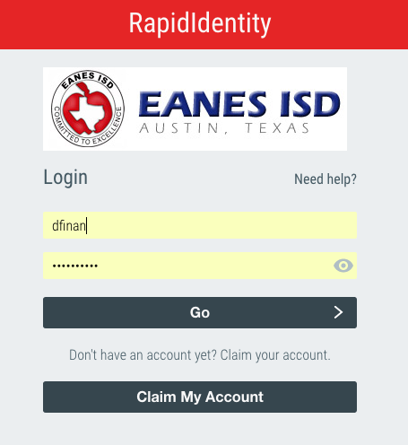
The RapidIdentity login information/password is the same as the student’s district username and password.

Click the button for the relevant resource:
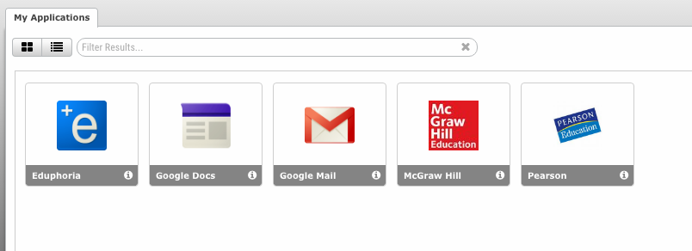

This button should direct students directly to their student account on the web. When students are logged in, they should see an option to launch the app. They will be able to launch the McGraw Hill app from the website. Then they can download their eTextbooks. (APPs must be downloaded on the iPad for these links to work)
